PRACTICAL -5
1.Shape areas: an abstract Shape with abstract area(); subclasses Circle, Rectangle,Triangle. Put a mix in a Shape[] and loop once to print each area and the running total, tracking the largest — one loop handling every shape through polymorphism.
CODE:
ShapeDemo.java
import java.util.Scanner;
abstract class Shape {
abstract double area();
}
class Circle extends Shape {
double radius;
Circle(double radius) {
this.radius = radius;
}
double area() {
return 3.14 * radius * radius;
}
}
class Rectangle extends Shape {
double length, width;
Rectangle(double length, double width) {
this.length = length;
this.width = width;
}
double area() {
return length * width;
}
}
class Triangle extends Shape {
double base, height;
Triangle(double base, double height) {
this.base = base;
this.height = height;
}
double area() {
return 0.5 * base * height;
}
}
public class ShapeDemo {
public static void main(String[] args) {
Scanner sc = new Scanner(System.in);
System.out.print("Enter radius of circle: ");
double radius = sc.nextDouble();
System.out.print("Enter length of rectangle: ");
double length = sc.nextDouble();
System.out.print("Enter width of rectangle: ");
double width = sc.nextDouble();
System.out.print("Enter base of triangle: ");
double base = sc.nextDouble();
System.out.print("Enter height of triangle: ");
double height = sc.nextDouble();
Shape[] shapes = {
new Circle(radius),
new Rectangle(length, width),
new Triangle(base, height)
};
double total = 0;
double largest = 0;
for (Shape s : shapes) {
double a = s.area();
System.out.println("Area = " + a);
total = total + a;
if (a > largest) {
largest = a;
}
}

System.out.println("Total Area = " + total);
System.out.println("Largest Area = " + largest);

sc.close();
}
}
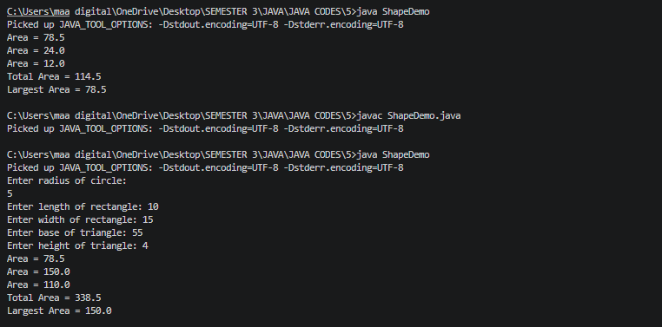

2. Payroll: an abstract Employee with abstract monthlySalary(); FullTime (fixed), PartTime (hours × rate) and Intern (stipend), each calling super for the shared name/id. Loop a mixed array to print each salary and the total; use instanceof to add a note only for interns.
Code:
import java.util.Scanner;
abstract class Employee {
String name;
int id;
Employee(String name, int id) {
this.name = name;
this.id = id;
}
abstract double monthlySalary();
}
class FullTime extends Employee {
double salary;
FullTime(String name, int id, double salary) {
super(name, id);
this.salary = salary;
}
double monthlySalary() {
return salary;
}
}
class PartTime extends Employee {
int hours;
double rate;
PartTime(String name, int id, int hours, double rate) {
super(name, id);
this.hours = hours;
this.rate = rate;
}
double monthlySalary() {
return hours * rate;
}
}
class Intern extends Employee {
double stipend;
Intern(String name, int id, double stipend) {
super(name, id);
this.stipend = stipend;
}
double monthlySalary() {
return stipend;
}
}
public class PayrollDemo {
public static void main(String[] args) {
Scanner sc = new Scanner(System.in);
Employee[] employees = new Employee[3];
// Full-Time Employee
System.out.println("Enter Full-Time Employee Details");
System.out.print("Enter name: ");
String name1 = sc.nextLine();
System.out.print("Enter ID: ");
int id1 = sc.nextInt();
System.out.print("Enter monthly salary: ");
double salary = sc.nextDouble();
employees[0] = new FullTime(name1, id1, salary);
sc.nextLine();
// Part-Time Employee
System.out.println("\nEnter Part-Time Employee Details");
System.out.print("Enter name: ");
String name2 = sc.nextLine();
System.out.print("Enter ID: ");
int id2 = sc.nextInt();
System.out.print("Enter working hours: ");
int hours = sc.nextInt();
System.out.print("Enter rate per hour: ");
double rate = sc.nextDouble();
employees[1] = new PartTime(name2, id2, hours, rate);
sc.nextLine();
// Intern
System.out.println("\nEnter Intern Details");
System.out.print("Enter name: ");
String name3 = sc.nextLine();
System.out.print("Enter ID: ");
int id3 = sc.nextInt();
System.out.print("Enter stipend: ");
double stipend = sc.nextDouble();
employees[2] = new Intern(name3, id3, stipend);
// Calculate salaries
double total = 0;
System.out.println("\n--- Payroll Details ---");
for (Employee e : employees) {
double salaryAmount = e.monthlySalary();
System.out.println("Name: " + e.name);
System.out.println("ID: " + e.id);
System.out.println("Monthly Salary: " + salaryAmount);
if (e instanceof Intern) {
System.out.println("Note: This employee is an Intern");
}
System.out.println();
total = total + salaryAmount;
}
System.out.println("Total Salary = " + total)
sc.close();
}
}

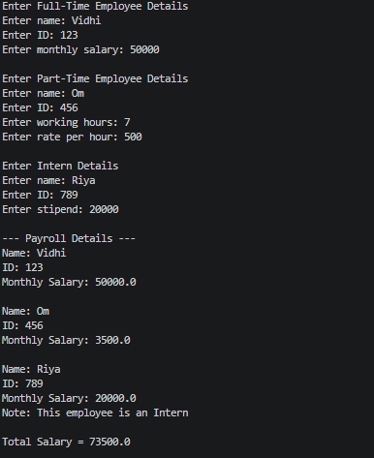

3. (For Advanced Learners – home) Model a few media types that each compute a late fee differently and total the fees for a returned batch. Design the hierarchy and rules yourself.
Code:
import java.util.Scanner;
abstract class Media {
String title;
int lateDays;
Media(String title, int lateDays) {
this.title = title;
this.lateDays = lateDays;
}
abstract double lateFee();
}
class Book extends Media {
Book(String title, int lateDays) {
super(title, lateDays);
}
double lateFee() {
return lateDays * 2;
}
}
class DVD extends Media {
DVD(String title, int lateDays) {
super(title, lateDays);
}
double lateFee() {
return lateDays * 5;
}
}
class Magazine extends Media {
Magazine(String title, int lateDays) {
super(title, lateDays);
}

double lateFee() {
return lateDays * 1;
}
}
public class MediaDemo {
public static void main(String[] args) {
Scanner sc = new Scanner(System.in);
Media[] media = new Media[3];
// Book
System.out.println("Enter Book Details");
System.out.print("Enter title: ");
String bookTitle = sc.nextLine();
System.out.print("Enter late days: ");
int bookDays = sc.nextInt();
media[0] = new Book(bookTitle, bookDays);
sc.nextLine();
// DVD
System.out.println("\nEnter DVD Details");
System.out.print("Enter title: ");
String dvdTitle = sc.nextLine();
System.out.print("Enter late days: ");
int dvdDays = sc.nextInt();
media[1] = new DVD(dvdTitle, dvdDays);
sc.nextLine();
// Magazine
System.out.println("\nEnter Magazine Details");
System.out.print("Enter title: ");
String magazineTitle = sc.nextLine();
System.out.print("Enter late days: ");
int magazineDays = sc.nextInt();
media[2] = new Magazine(magazineTitle, magazineDays);
// Calculate fees
double total = 0;
System.out.println("\n--- Late Fee Details ---");
for (Media m : media) {
double fee = m.lateFee();
System.out.println("Title: " + m.title);
System.out.println("Late Days: " + m.lateDays);
System.out.println("Late Fee: Rs. " + fee);
System.out.println();
total = total + fee;
}
System.out.println("Total Late Fee = Rs. " + total);
sc.close();
}
}
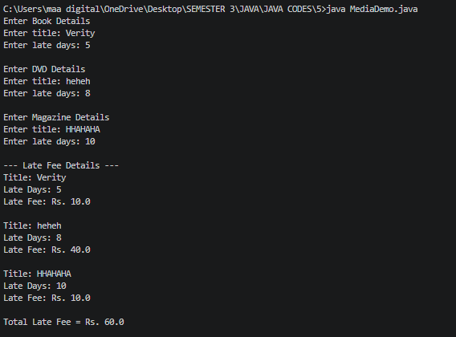

Part B — Project Work (Hour 2): MiniBank
A real bank has different account types. Building on the single Account class, this lab makes
Account abstract and adds three subclasses — SavingsAccount, CurrentAccount and
FixedDepositAccount — each with its own interest and withdrawal rules chosen
automatically by polymorphism. This lets the rest of MiniBank treat every account through
one common type.
1. Make Account an abstract class. Add two abstract methods: double interestRate() and
boolean canWithdraw(long amount).
2. Create a class SavingsAccount that extends Account with a long field minBalance;
interestRate() returns 4.0; canWithdraw() returns true only if the balance stays greater
than or equal to minBalance.
3. Create a class CurrentAccount that extends Account with a long field overdraftLimit;
interestRate() returns 0; canWithdraw() allows the balance to fall to minus
overdraftLimit.
4. Create a class FixedDepositAccount that extends Account; interestRate() returns 7.0;
canWithdraw() returns false (the deposit is locked).
5. Call super(...) from each subclass constructor to initialise the inherited fields.
6. In main, place objects of the three types in an Account[] array, loop through it and call
interestRate() on each (this demonstrates run-time polymorphism); use a pattern
instanceof check to handle one type specially.
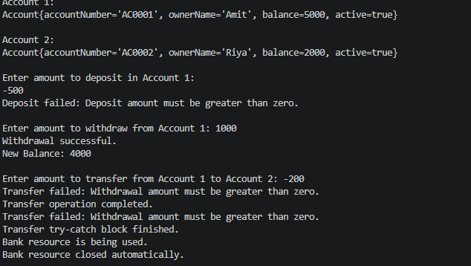
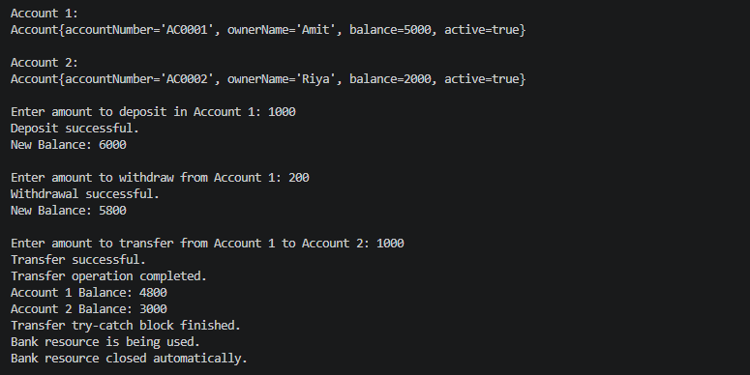
Learning Outcomes
After completing these programs, students will be able to:
- Understand abstract classes and methods by creating common Shape and Employee classes.
- Apply inheritance and polymorphism to handle different types of shapes and employees using a single array.
- Implement method overriding to calculate different areas and salaries for different subclasses.
- Use loops and arrays to process multiple objects and calculate totals and largest values.
- Use instanceof to identify specific object types such as Intern.
- Understand real-world object-oriented design by modelling different media types with their own late-fee rules.
- Strengthen OOP concepts such as abstraction, inheritance, polymorphism, and dynamic method dispatch.

